Fundamental of Supply Chain: Transportation Mode

Student’s Name
Institutional Affiliation
Course
Professor
Date

Fundamental of Supply Chain: Transportation Mode
Transportation of animals can be referred to as the intentional movement of animals by transport. The common types of animals that are transferred from one place to another destiny include livestock for slaughter or sale purposes, pets and wild animals for rescue or relocation. The transportation mode used differs due to the diverse nature and characteristics of different species as well as the method of transport. The distance between two destinies also plays a significant role in determining the most suitable way of transport. The focus of the paper will be an analysis of the case study on how to transport orcas from Oak Bay Marina through Florida to Texas Seaworld in the United States. It is not just amazing how orcas are trained to follow people’s instructions but also how such huge animals are transported from one place to another.
Orcinus Orca also is known as the killer whale is a species of the dolphin family and considered the largest member. An orca can feed on a variety of food, but individuals specialize in one particular or several types of prey. One kind of whale feeds on aquatic mammals such as other smaller dolphins and seals while others feed on specific fish. Besides, there have been many cases of an orca attacking both calves and adult whales. Even though the orcas are considered as the apex or tertiary predators, their population is threatened to extinct. Orcas are not a threat to the human community, but cases of orcas killing or injuring both at the oceans and theme parks are alarming. Besides, human activities that cause water population is a threat to orcas. Killer whales are very social animals; some of the species consist of matrilineal family groups which are regarded as favourable for any species of animals. Matrilineal is a kingship that constitutes the female linage and whereby a whale/person is identified through his mother’s heredity (Jett &Ventre, 2015). The specific vocal and hunting technique known within a family is passed from one generation of whales to another, thus known as animal culture. Orcas are found in particular oceans while lay from arctic and Antarctic regions to those within the tropical areas. Orcas are not found in Black seas, Baltic Sea and some of the seas within the northern part.
Transportation Modes in Supply Chain
Generally, there are five modes of transport around the world. They include railways, roadways, pipelines, airways, and waterways. A combination of two or more modes of transportation is known as modal or multi-modal transportation. Every method of transport has its advantages and disadvantage. For instance, in the evaluation of railway mode of transport, it is found to be economical since it transports bulky goods for long distances at low prices. The railway can carry large and heavy products uninterrupted by the weather changes across international markets. However, this mode of transportation is costly over a short distance, slow and faced with excessive delays.
There are two ways in which aquatic mammals can be transported from one destination to another. First, marine animals can be carried through wet transit. This is whereby they are kept in a tank of water and apply to species that cannot survive without water such as fish. Others are transported through dry transit. Animals transferred through this method require just enough water to keep them cold and moist. Such species include seals. An example of an event that utilized the wet transit method comprises in a popular film known as Free Willy. Willy, in the movie, is a killer whale that was like Keiko. He was moved using a trailer from the orogeny Coast Aquarium to the airport whereby he was later airlifted by United Parcel Service and eventually by the U.S Air force C-17 transport.
Transport Route from Oak Bay Marina to SeaWorld Florida
The Oak Bay Marina is located in British Columbia Canada adjacent to the city of victoria. The Oak Bay Marina consisted of an aquarium that was highly populated by orcas but unfortunately, they were hunted down and captured locally. The management of the theme park decided to transfer the left mammals to other theme parks, for instance, SeaWorld in the Florida United States. The distance between the two points is 5, 186 kilometres and takes about 50 hours by road. That is for about two days and two nights. Through the air, the same distance will be covered within 7 hours and 35 minutes. The two points also can be joined by a road that passes through Los Angeles through Texas and to Florida. A train will take about five days and 10 hours. Since it is a long-distance, the best transport mode to be used to transfer orcas from the oak bay marina to SeaWorld in Florida is a combination of several methods which consist of road and airway.
Orcas being a marine mammal species, it will be transported through wet transit whereby it will be placed in a tank full of water. From the Oak Bay beach to Victoria International Airport the specie will be transported in the trailer since it is economical over a short distance as compared to the railway. Besides, since the gap between the beach and the airport is short, the road is the fastest mode of transport and more flexible. However, despite its merits over a short distance, the road cannot be used to transport large cargo like orcas over a long distance (Flannelly et al., 1991). The reason is, it is much slower as compared to air due to many stopovers, the risk to accidents, unfriendly to weather changes, costly due to fuel and punctures and limitations across the border.
At the arrival in victoria international airport, the container should be airlifted to Orlando international airport, a few kilometres away from the Seaworld Florida beach. This option is chosen due to its nature of fish speed to cover to a long distance within a short time, especially in transporting live animals. Alive animals are treated as perishable goods since long time hunger or exposure to different temperatures can cause death. Even though the airway is not an all-weather friendly mode of transport, it is the preferable choice in the time of war, floods or earthquakes. Besides, there is less restriction along the crossing of the border between Canada and the United States. After its reach in Orlando international airport, the orcas should be loaded in the trailer to be transported to the SeaWorld Florida Ocean.
Transport Route from Florida to Texas
Consequently, the most appropriate way to transport orcas from Florida SeaWorld to Texas is through airways. The distance between the two destines is a two-hour flight which is much convenient as compared to other modes of transport. The point of departure would Orlando international air point and the arrival destination would be San Antonio international airport. The distance between the airport and Texas SeaWorld is sufficient through the use of trucks.
Challenges Faced In Transporting Orca
Capturing an orca from the ocean or pools is the first challenge faced by the transporters. Most people tend to raise the floor of the pool until no more water is left. Being an intelligent animal, the killer whale senses that it’s in danger. It tends to thrash its tails which is much more durable and can cause injuries, or death. Also, it produces loud and angry vocals which symbolized anger and ready to fight responses. To some extent, the killer whale may bite to kill.
Consequently, environmental factors such as temperature possess a danger while transporting orcas through the air. Orcas require a particular environmental control system setting while being handled, packed, and loaded in the plane. Maintenance of optimum temperature is challenging, especially during ground operations (East, 2019). During packing, stationary containers tend to get heated by the sunshine, and if not cooled during loading, the compartment tends to have high temperatures making the killer whale uncomfortable. Besides, the change of climate from one area to another tends to cause, death or other related health problems.
Delivery Plan
Nonetheless, the most appropriate mode of transport is not only the factor to consider enhancing the safe delivery of orcas, but also the environment in which the species are transported. Special designed trucks or trailers alongside the police escort should get the orcas to and from the airport. The individual designed containers or trailers purpose to enhance the comfort of the mammals and should be spacious to ensure the movements. Also, the most preferred type of plane is the jet due to its streamline shaped body. The shape enables the jet to cut more swiftly in the air compares to the helicopters, thus less friction to disturb the orcas.
Moreover, the interior of the plane needs to be customized to enhance the conducive environment for the “passenger”. For example, the interior of the aircraft needs to be reconfigured to accommodate an onboard laboratory in which the aquarium veterinarians can observe and monitor the behaviours of the killer whale (Tang, 2017). Also, the tank/container in which the killer whale is placed in need to be custom-made, foam-lined and well secured with strengthened slings. Besides, the environmental condition such as temperature and pressure should be adjusted to that of the natural environment habitat. Pilots also should take long, and shallow take off as well as landings and ensure to ensure slow mid-air turns to above flicking the orcas out.
.
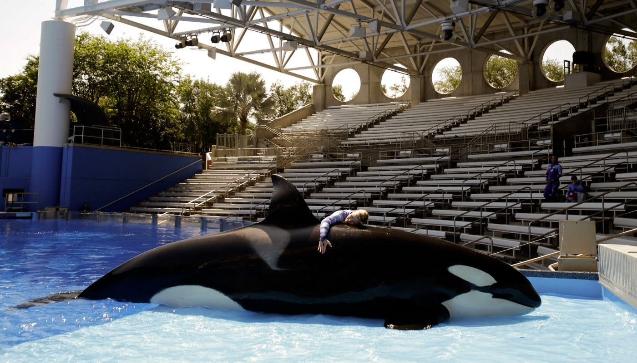
Fig 1: an employee developing a close bond with an Orca

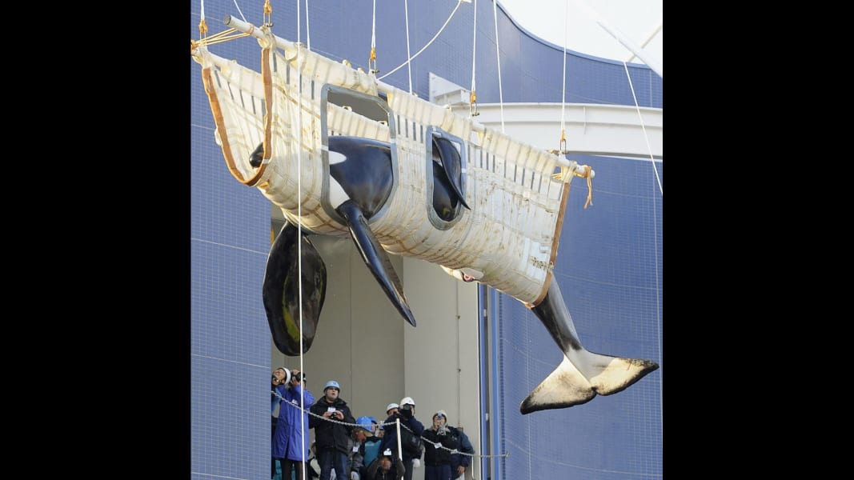
Fig 2: a killer lifted from Oak Bay Marina for transportation to Florida
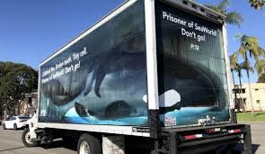

Fig 3: special truck to transport orca

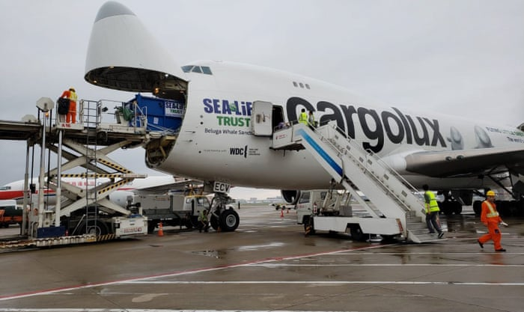
Fig 4: loading an orca in a plane

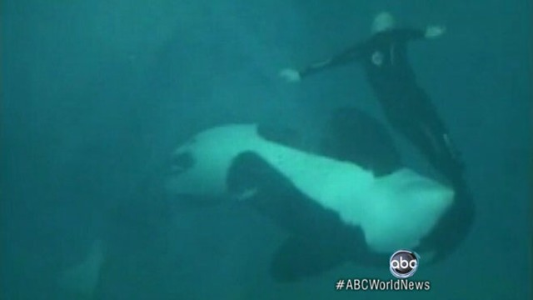
Fig 5: an orcas attacking a swimmer

References
East, R. (2019). Challenges faced when transporting animals by air. Cargo-wise.co.uk. Retrieved 2 April 2020, from https://www.cargo-wise.co.uk/blog/5-challenges-faced-when-transporting-animals-by-air.
Flannelly, K. J., McLeod Jr, M. S., Flannelly, L., &Behnke, R. W. (1991). DIRECT COMPARISON OF COMMUTERS'INTERESTS IN USING DIFFERENT MODES OF TRANSPORTATION. Transportation Research Record, (1321).
Jett, J., &Ventre, J. (2015).Captive killer whale (Orcinus orca) survival. Marine Mammal Science, 31(4), 1362-1377.
Tang, K. (2017). How Does SeaWorld Transport Animals?.Sciencing.Retrieved 2 April 2020, from https://sciencing.com/how-does-seaworld-transport-animals-13652532.html.

